**SQL Assignment 4**

**Query 1 Create a stored procedure in the Northwind database that will calculate the average value of Freight for a specified customer.**

**Then, a business rule will be added that will be triggered before every Update and Insert command in the Orders controller,and will use the stored procedure to verify that the Freight does not exceed the average freight. If it does, a message will be displayed and the**

**command will be cancelled.**

**Stored Procedure for finding average freight for specified customers.**

delimiter &&

create procedure avg_freight(IN customer_id varchar(5),OUT avg decimal(10,4))

begin

select avg(freight) into avg from orders where customerid = customer_id;

end &&

delimiter ;

call avg_freight("TOMSP",@avg_freight);

select @avg_freight as "Average Freight Value";

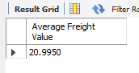

**Trigger of before import**

delimiter &&

create trigger verify_freight

before insert on orders

for each row

begin

declare msg varchar(100);

set msg = " The command cancelled due to Freight value exceed the average freight.";

call avg_freight(new.customerid,@avg_freight);

if @avg_freight < new.freight

then

signal sqlstate '45000' set message_text = msg;

end if;

end &&

delimiter ;

insert into orders values(10249,"TOMSP",6,"2022-02-04","2022-02-28","2022-03-10",2,22,null,null,null,null,null,null);



**Trigger of before update**

delimiter &&

create trigger verify_freight_update

before update on orders

for each row

begin

declare msg varchar(100);

set msg = " The command cancelled due to Freight value exceed the average freight.";

call avg_freight(new.customerid,@avg_freight);

if @avg_freight < new.freight

then

signal sqlstate '45000' set message_text = msg;

end if;

end &&

delimiter ;

update orders set freight = 22 where customerid = "TOMSP";



**Query 2 write a SQL query to Create Stored procedure in the Northwind database to retrieve Employee Sales by Country.**

delimiter &&

create procedure employee_sales_by_country(IN country varchar(15))

begin

select employees.Firstname,employees.Lastname,count(orderid) as "Sales",ShipCountry from employees left join orders on employees.employeeid = orders.employeeid where shipcountry = country group by shipcountry,firstname,lastname;

end &&

delimiter ;

call employee_sales_by_country("Mexico");

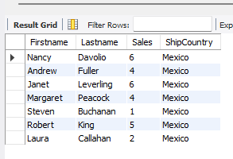

**Query 3 write a SQL query to Create Stored procedure in the Northwind database to retrieve Sales by Year.**

delimiter &&

create procedure sales_by_year(IN starting_date varchar(20),IN ending_date varchar(20))

begin

select count(orderid) as "Total Sale" from orders where shippeddate between starting_date and ending_date;

end &&

delimiter ;

call sales_by_year("1998-01-01","1998-12-31");

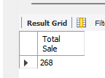

**Query 4 write a SQL query to Create Stored procedure in the Northwind database to retrieve Sales By Category.**

delimiter &&

create procedure sales_by_category(IN category_name varchar(40))

begin

select count(orderid) as "Total sale" from `order details` left join products on products.productid = `order details`.productid

left join categories on products.categoryid = categories.categoryid where categoryname = category_name;

end &&

delimiter ;

call sales_by_category("Dairy Products");

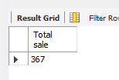

**Query 5 write a SQL query to Create Stored procedure in the Northwind database to retrieve Ten Most Expensive Products.**

delimiter &&

create procedure print_top_ten()

begin

select ProductName,UnitPrice from Products order by UnitPrice desc limit 10;

end &&

delimiter ;

call print_top_ten();

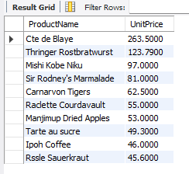

**Query 6 write a SQL query to Create Stored procedure in the Northwind database to insert Customer Order Details.**

delimiter &&

create procedure insert_order_detail(IN order_id int,IN product_id int,IN price decimal(10,4),IN quantities smallint,IN discounts double(8,0))

begin

insert into `order details` values (order_id,product_id,price,quantities,discounts);

end &&

delimiter ;

call insert_order_detail(10393,12,200.00,6,0);



select * from `order details` where orderid = 10393 and productid = 12;

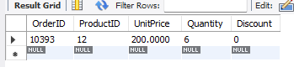

**Query 7 write a SQL query to Create Stored procedure in the Northwind database to update Customer Order Details.**

delimiter &&

create procedure update_order_detail(IN order_id int,IN product_id int,IN price decimal(10,4),IN quantities smallint,IN discounts double(8,0))

begin

update `order details` set unitprice = price,quantity = quantities,discount = discounts where

orderid = order_id and productid = product_id;

end &&

delimiter ;

call update_order_detail(10393,12,400,12,0.1);



select * from `order details` where orderid = 10393 and productid = 12;

